**Lesson 1.2. Create a Network from the scratch**

# Create a Network by Yourself: Create a Directed Network

Learning objectives:

1. How to create a network by yourself.

2. How to adjust network elements size.

3. How to edit and view the attributes of Network.

4. How to create a network from the background map image.

5. How to verify the network connectivity.

## Step 1: Run NeXTA

Step 1.1: First, run NeXTA.exe, resulting in the following screen.

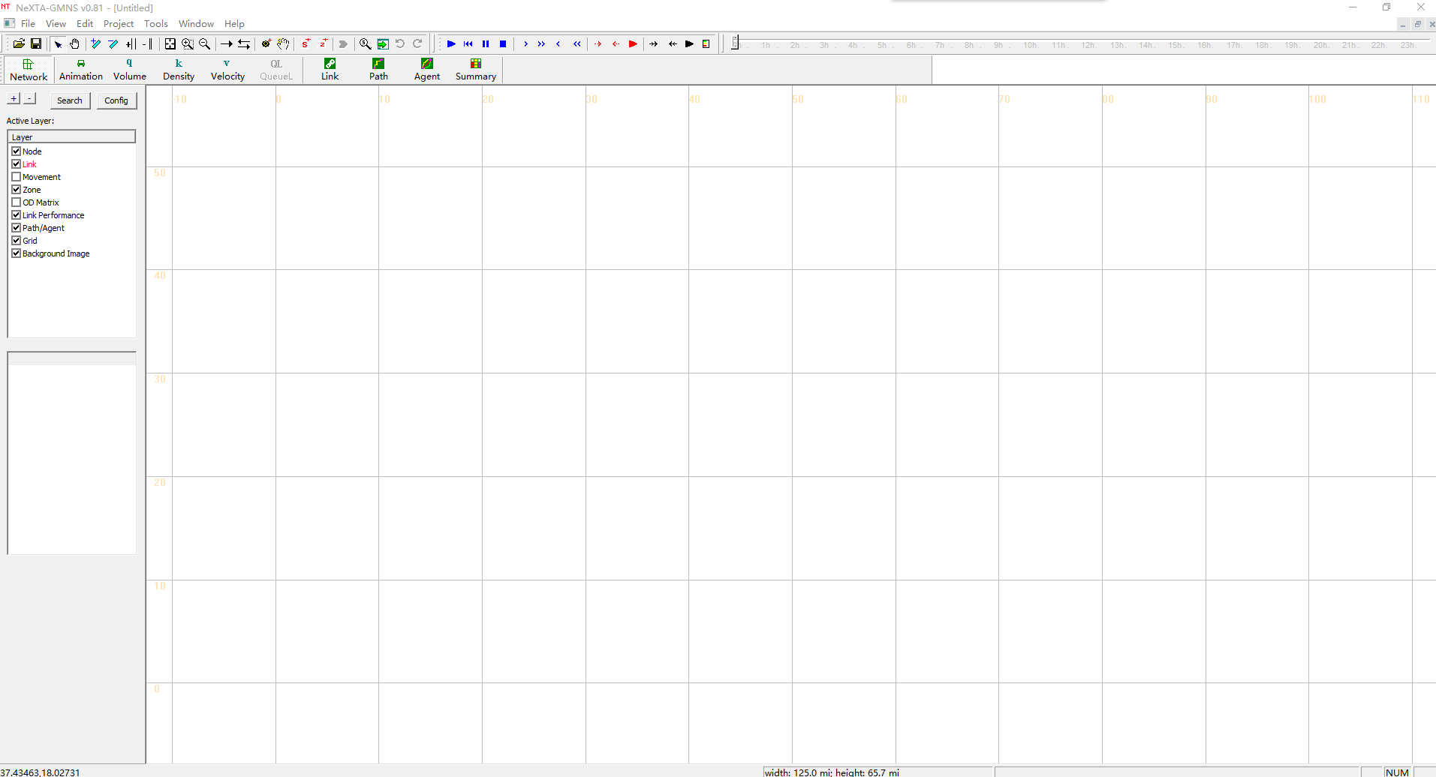

## Step 2: Add new one-way links

Related toolbar buttons:

C:\Users\So_So\AppData\Local\Temp\1600303899(1).png

Step 2.1: Press the “Link”  toggle button.

Step 2.2: Press the left mouse on the location you want the link to start. This could be on an existing node or where no node currently exists. Move the cursor to the desired end of the link. Now release the left mouse on the location you want the link to end. Again, this can be on a node or not. A link will be created between these two locations, as shown below:

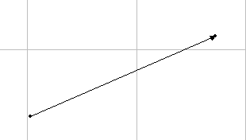

## Step 3: Add multiple connected links

Related toolbar buttons:

C:\Users\So_So\AppData\Local\Temp\1600303899(1).png, C:\Users\So_So\AppData\Local\Temp\1600305011(1).png

Step 3.1: Press the “Link”  toggle button.

Step 3.2: Add an one-way link according to Step2.

Step 3.3: Press the left mouse on the location you want the link to start. A set of links will be created between these two locations as, as shown below:

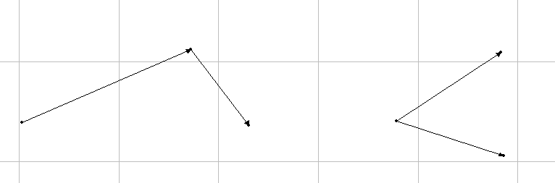

Step 3.4: Press the C:\Users\So_So\AppData\Local\Temp\1599288866(1).pngtoggle button and adjust node size. It is obvious that the link (1,2) is connected with link(2,3), as shown below:

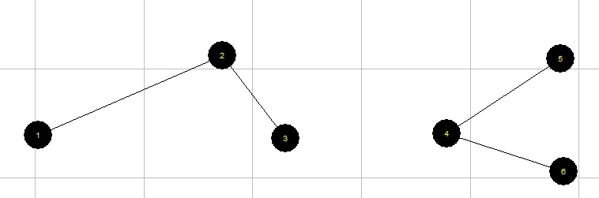

## Step 4: Create a Network

Step 4.1: Repeat Step3.1-Step3.3 and create a network, as shown below:

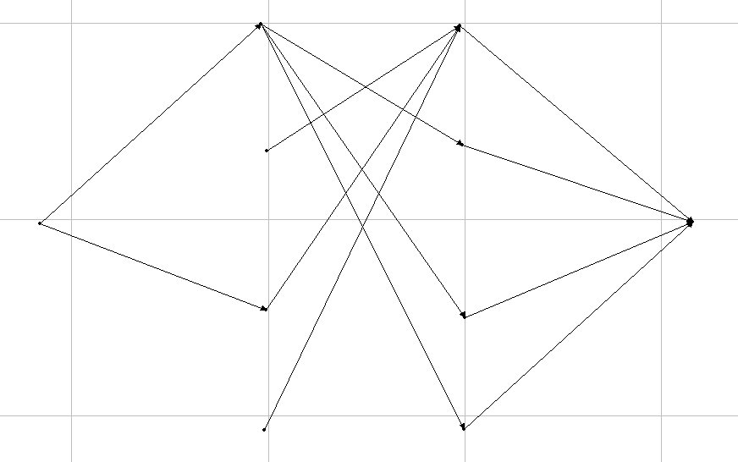

## Step 5: Adjust node size for display

Related toolbar buttons:

C:\Users\So_So\AppData\Local\Temp\1600305011(1).png

Step 5.1: Press the C:\Users\So_So\AppData\Local\Temp\1599288866(1).png toggle button and adjust node size, as shown below:

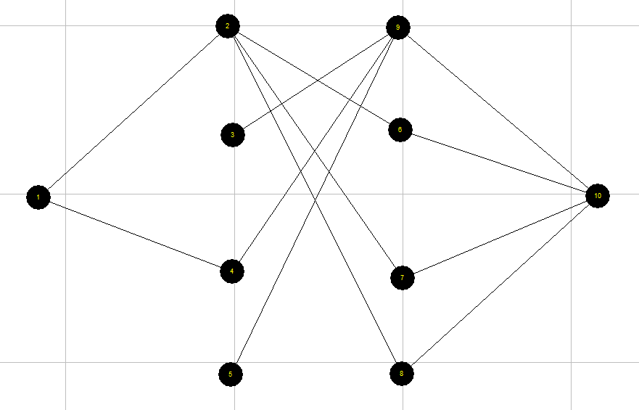

## Step 6: Edit and view the attribute of a link

Related toolbar buttons:

C:\Users\So_So\AppData\Local\Temp\1600308573(1).png

Step 6.1: Click the “select” C:\Users\So_So\AppData\Local\Temp\1599290815(1).png toggle button.

Step 6.2: Click the “link” layer in the “Active layer panel”, the corresponding layer is then highlighted in red, as shown below:

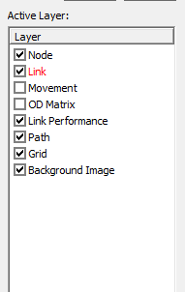

Step 6.3: Click on the link to select it.

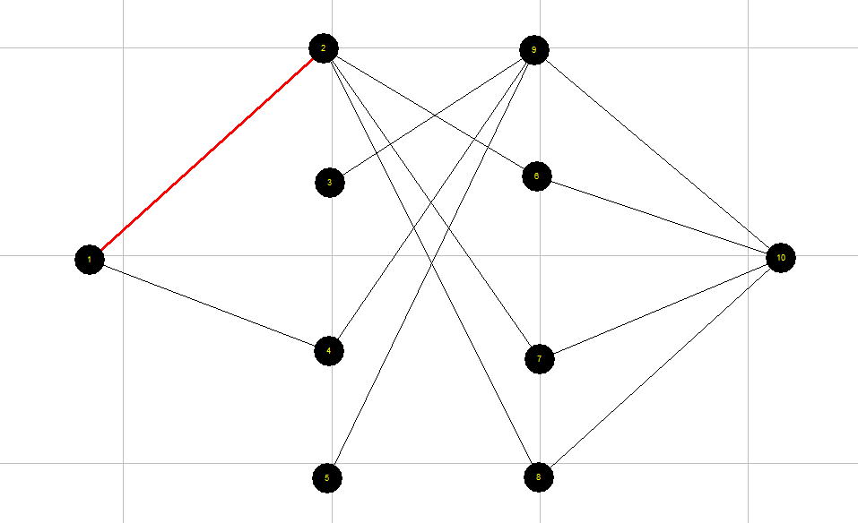

Step 6.4: Click the right mouse on the position of a selected link and you can select to view or edit the attributes of the selected link, as shown below:

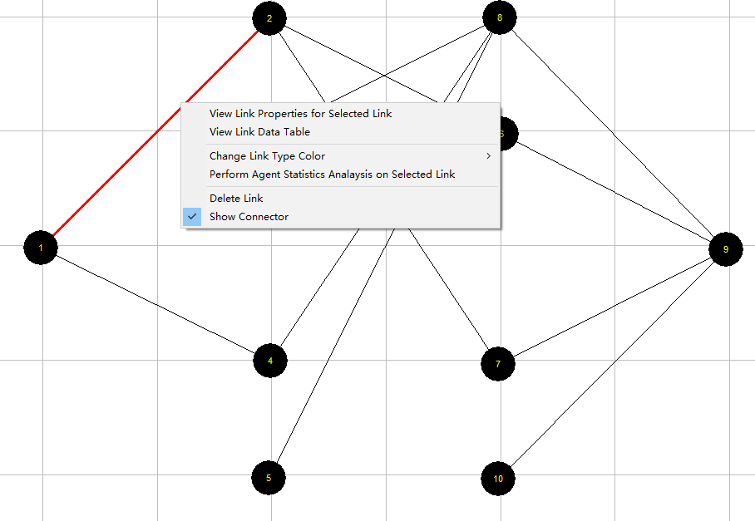

## Step 7: Edit and view the attributes of a node

Related toolbar buttons:

C:\Users\So_So\AppData\Local\Temp\1600308573(1).png

Step 6.1: Click the “select” C:\Users\So_So\AppData\Local\Temp\1599290815(1).png toggle button.

Step 6.2: Click the “node” layer in the “Active layer panel”, as shown below:

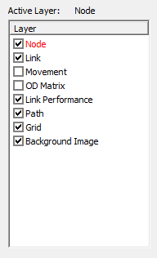

Step 6.3: Click on the node and then it will be selected, as shown below:

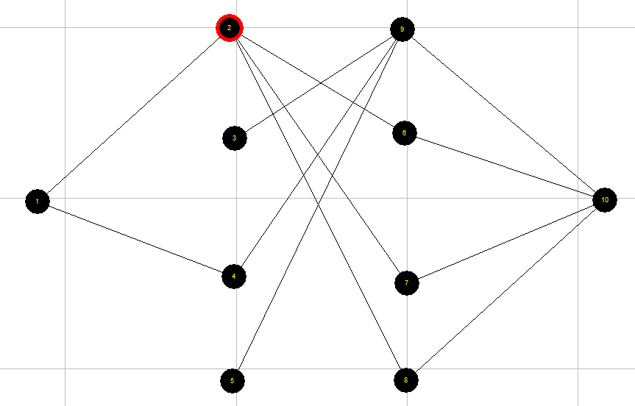

Step 6.4: Click the right mouse on the position of selected node and you can select to view or edit the attributes of the selected node, as shown below:

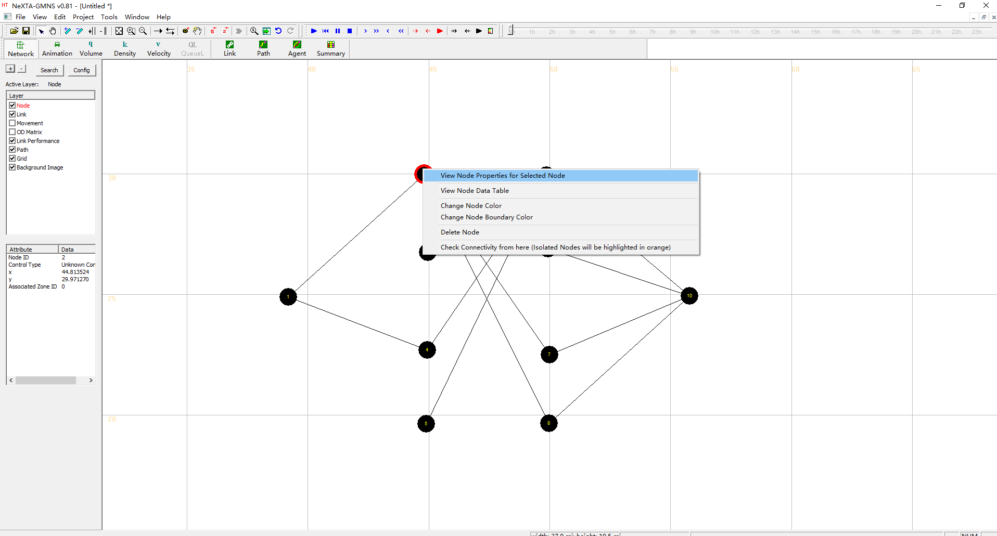

## Step 8: Save GMNS data of node and link csv files

Related toolbar buttons:

C:\Users\So_So\AppData\Local\Temp\1600308573(1).png

Step 8.1: Click the “save” C:\Users\So_So\AppData\Local\Temp\1599293140(1).png toggle button and to save the files of “node.csv” and “link.csv” to the local project folder.

# Create a Network from the background map image: Create a Traffic Network

## Step 1: Create a new project folder with 3 files: image.bmp, image.ini, and node.csv

Step 1.1: First, prepare a map image in the BMP format and rename it as “image.bmp”.

Step 1.2: Prepare an “image.ini” file in Notepad with the following value for the real world width (the unit could be mile or km).

*[image]*

*real\_world\_width=20*

Step 1.3: Create a csv file and rename it as “node.csv”. This can be empty.

Step 1.4: Put all the files and NeXTA.exe in the new project folder, as shown below:

## Step 2: Run NeXTA to load node.csv

Step 2.1: First, double click and run NeXTA.exe, resulting in the following screen.



## Step 3: Verify if the background image is automatically loaded.

Step 3.1: Click the “link” layer in the “Active layer panel”, as shown below:

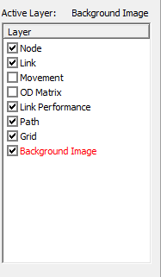

Step 3.2: Click “file menu” and select “Open Traffic Network Project”. Then, open the “node.csv” in the new window, as shown below:

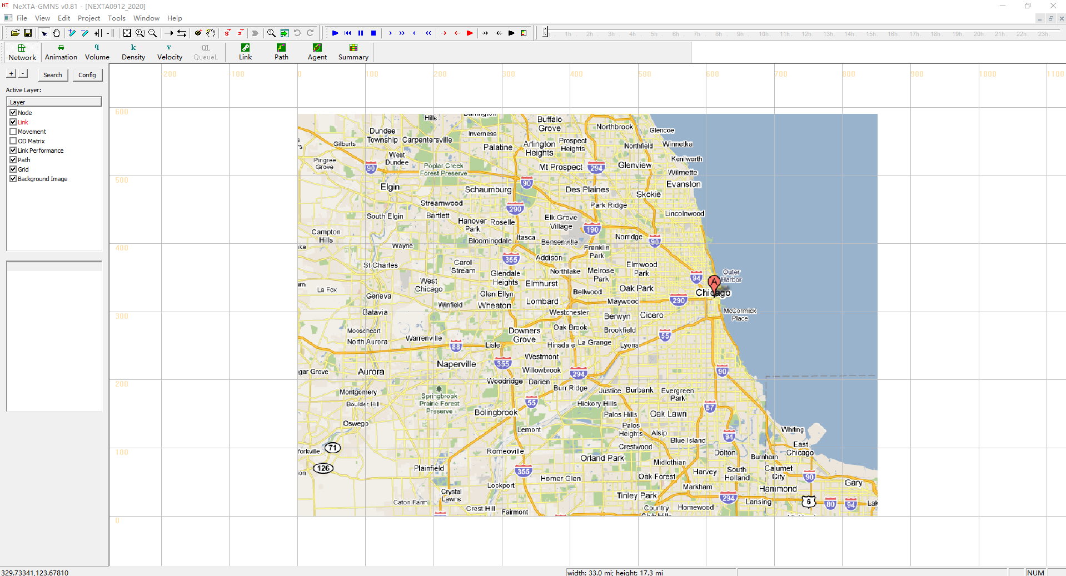

## Step 4: Add a sequence of new two-way links based on background image

## Step 5: Create a Traffic Network

Step 5.1: Repeat Step 4 and create a traffic network, as shown below:

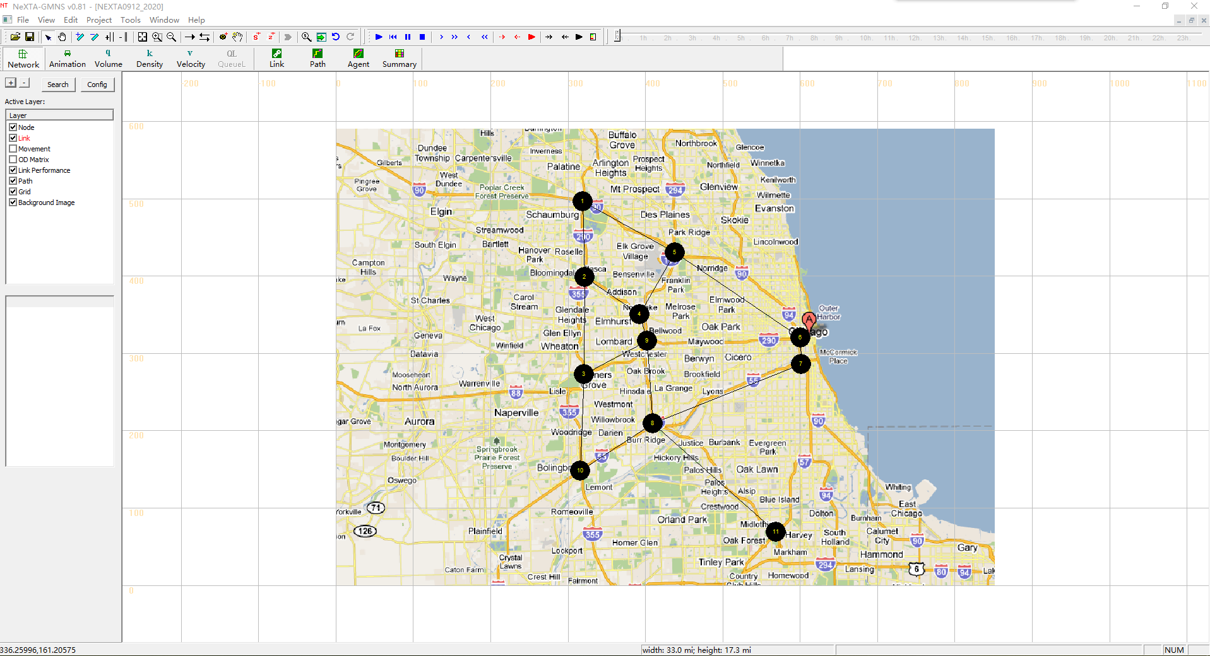

Step 5.2: Click the “Background Image” layer in the “Active layer panel” and close it, as shown below:

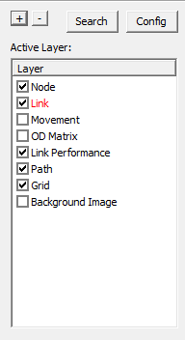

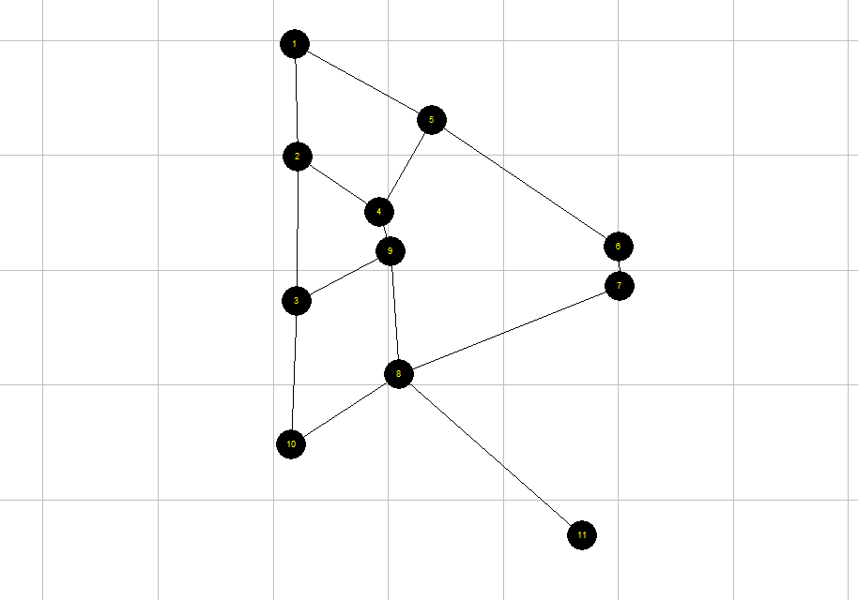

## Step 6: Verify the network connectivity by searching the shortest path between a pair of nodes

Step 6.1: Click the “Path” layer in the “Active layer panel”, as shown below:

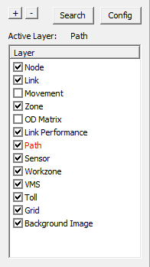

Fig 26 Select Path layer

Step 6.2: Click the right mouse on the location you want to start, and select “Direction from here”. This should be on an existing node. Move the cursor to the desired destination. Click the right mouse on the location you want to arrive, and select “Direction to here”, as shown below:

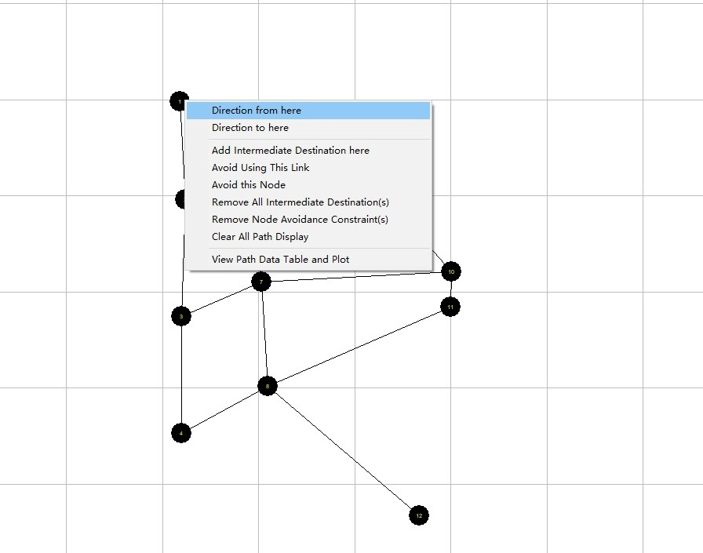

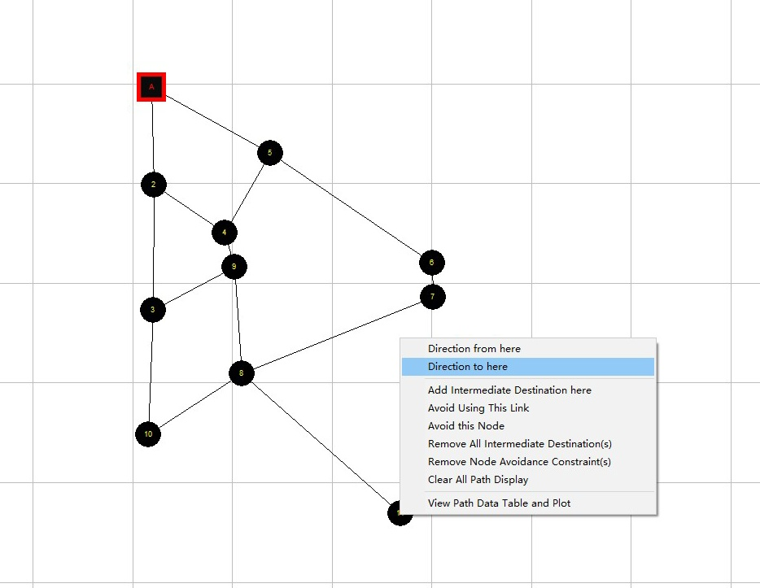

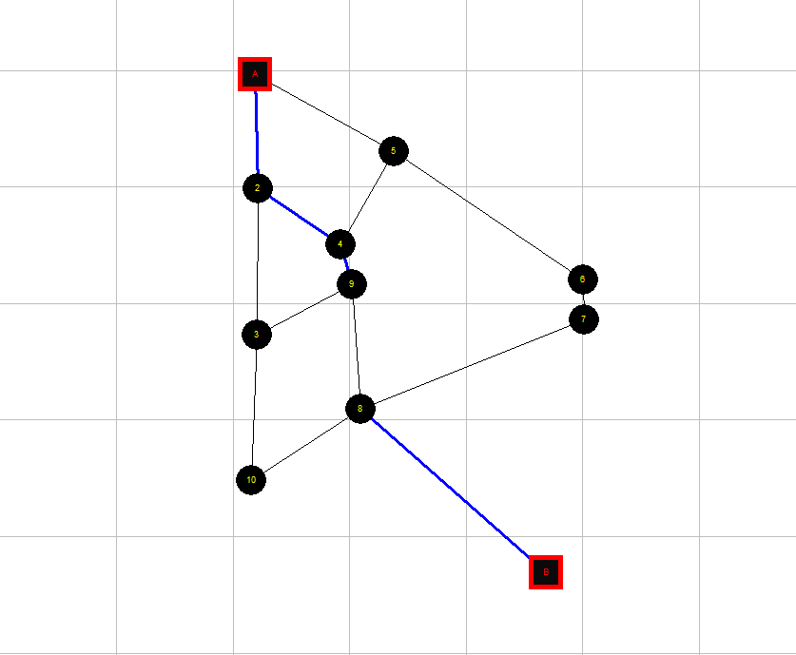

Step 6.3: Click the right mouse on the location where next to the path, and select “View Path Data Table and Plot”, as shown below:

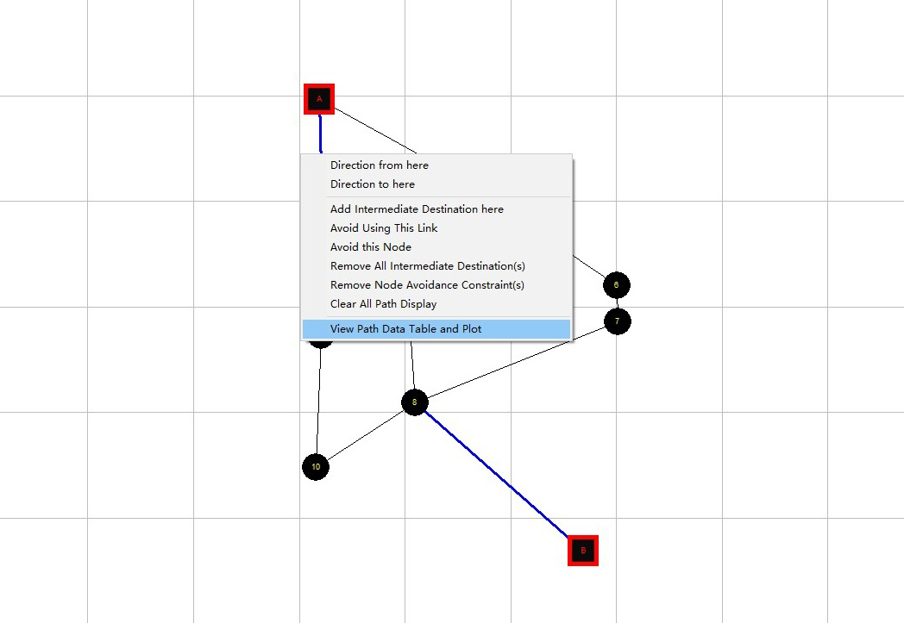

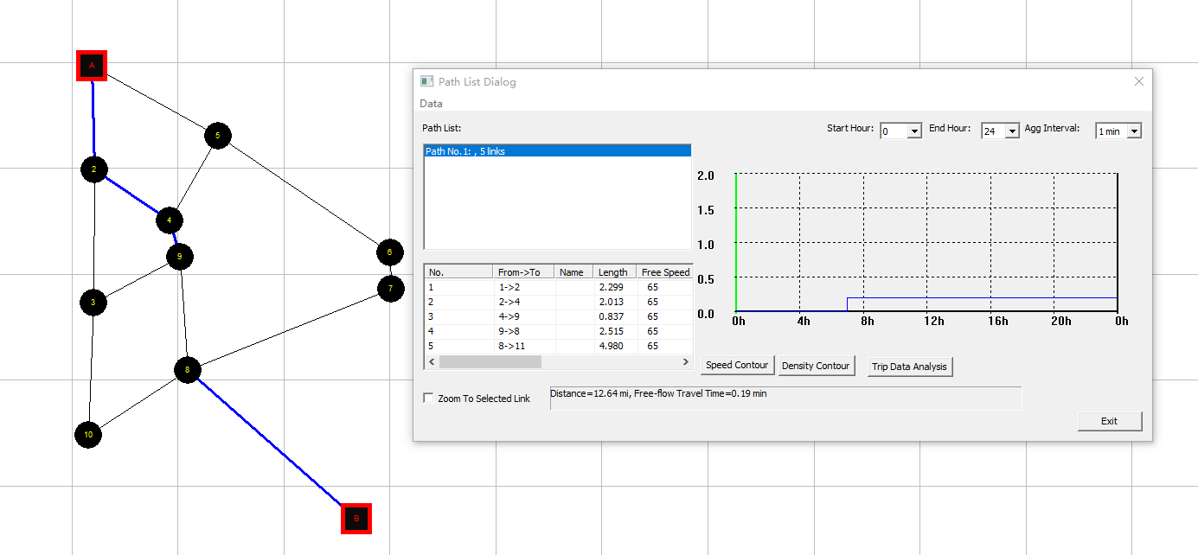

Step 6.4: Click the right mouse on the location where next to the path, and chose “Clear All Path Display” to clear paths, as shown below:

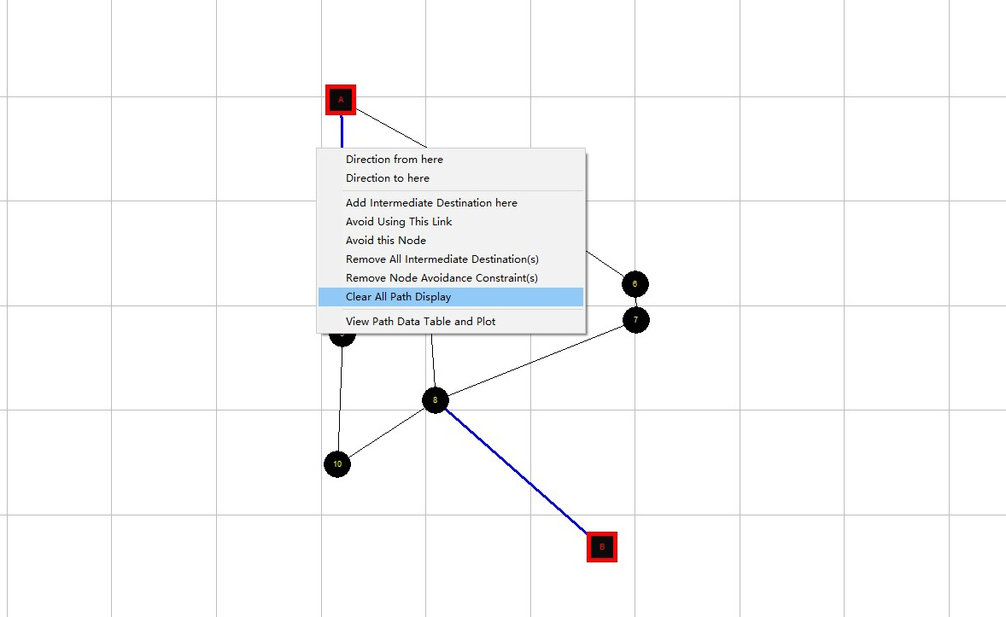

## Step 7: Try an action of deleting a link

Related toolbar buttons:

C:\Users\So_So\AppData\Local\Temp\1600395962(1).png

Step 7.1: Press the “mouse” C:\Users\So_So\AppData\Local\Temp\1600396008(1).png toggle button.

Step 7.2: Click the “link” layer in the “Active layer panel”, as shown below:



Step 7.3: Click the left mouse on the link which you want to delete, as shown below:

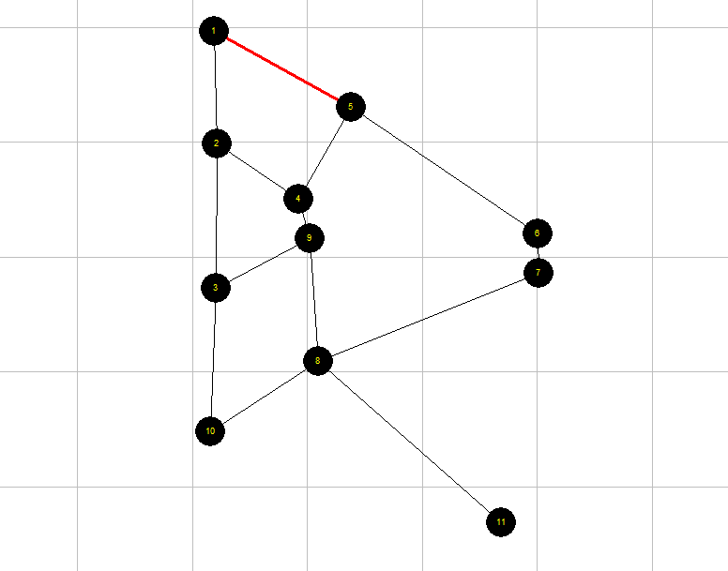

Step 7.4: Click the right mouse on the link which you want to delete and select “Delete Link”, as shown below:

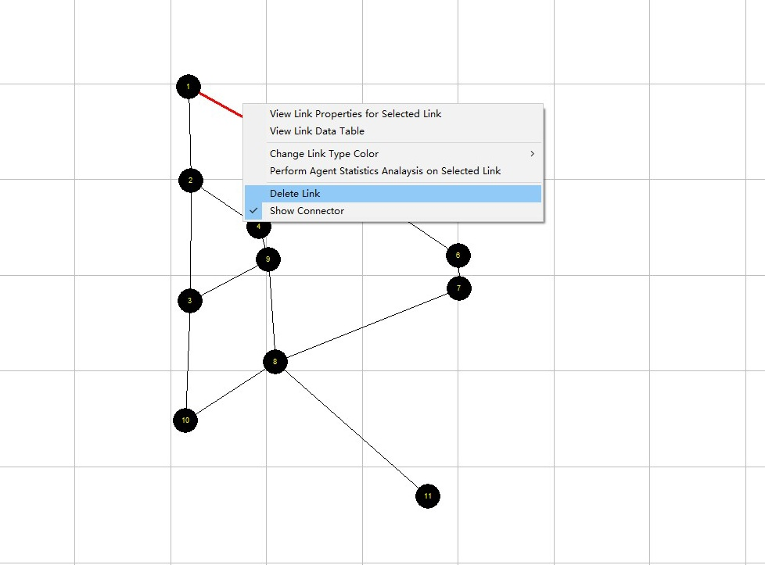

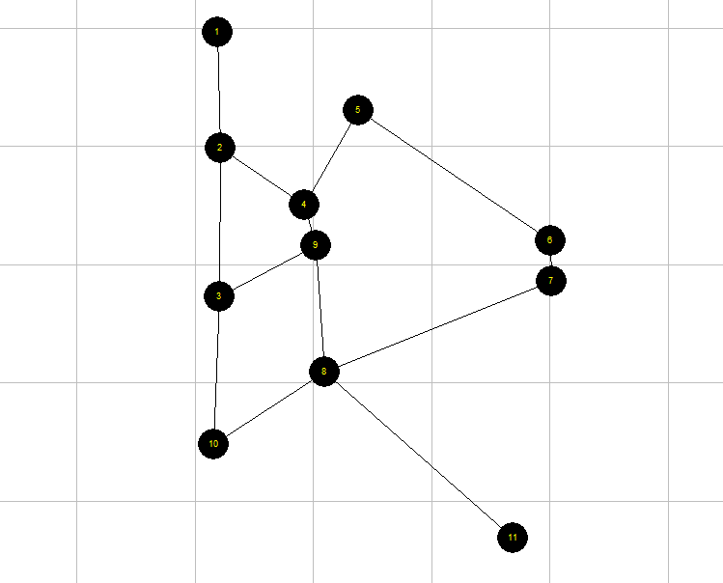

## Step 8: Save GMNS data file

Related toolbar buttons:

C:\Users\So_So\AppData\Local\Temp\1600308573(1).png

Step 8.1: Click the “save” C:\Users\So_So\AppData\Local\Temp\1599293140(1).png toggle button and to save the files of “node.csv” and “link.csv” to the local project folder.